Konark Sun Temple
Konark Sun Temple is a 13th-century CE Hindu Sun temple at Konark about 35 kilometres (22 mi) northeast from Puri city on the coastline in Puri district, Odisha, India.The temple is attributed to king Narasingha Deva I of the Eastern Ganga dynasty about 1250 CE.Dedicated to the Hindu Sun-god Surya, it reflects the pinnacle of Kalingan architecture and artistic excellence, what remains of the temple complex has the appearance of a 30-metre (100 ft) high chariot with immense wheels and horses, all carved from stone. Once over 61 metres (200 ft) high,much of the temple is now in ruins, in particular the large shikara tower over the sanctuary; at one time this rose much higher than the mandapa that remains. The structures and elements that have survived are famed for their intricate artwork, iconography, and themes, including erotic kama and mithuna scenes. Also called the Surya Devalaya, it is a classic illustration of the Odisha style of Architecture or Kalinga architecture.
The cause of the destruction of the Konark temple is unclear and still remains a source of controversy. Theories range from natural damage to deliberate destruction of the temple in the course of being sacked several times by Muslim armies between the 15th and 17th centuries. This temple was called the "Black Pagoda" in European sailor accounts as early as 1676 because it looked like a great tiered tower which appeared black.Similarly, the Jagannath Temple in Puri was called the "White Pagoda". Both temples served as important landmarks for sailors in the Bay of Bengal.The temple that exists today was partially restored by the conservation efforts of British India-era archaeological teams. Declared a UNESCO World Heritage Site in 1984, it remains a major pilgrimage site for Hindus, who gather here every year for the Chandrabhaga Mela around the month of February.
Konark Sun Temple is depicted on the reverse side of the Indian currency note of 10 rupees to signify its importance to Indian cultural heritage.
Architectural description
The Konark Sun Temple was built in 1250 CE during the reign of the Eastern Ganga King Narasingha Deva I from stone in the form of a giant ornamented chariot dedicated to the Sun god, Surya. In Hindu Vedic iconography Surya is represented as rising in the east and traveling rapidly across the sky in a chariot drawn by seven horses. He is described typically as a resplendent standing person holding a lotus flower in both his hands, riding the chariot marshaled by the charioteer Aruna.The seven horses are named after the seven metres of Sanskrit prosody: Gayatri, Brihati, Ushnih, Jagati, Trishtubh, Anushtubh, and Pankti.Typically seen flanking Surya are two females who represent the dawn goddesses, Usha and Pratyusha. The goddesses are shown to be shooting arrows, a symbol of their initiative in challenging the darkness. The architecture is also symbolic, with the chariot's twelve pairs of wheels corresponding to the 12 months of the Hindu calendar, each month paired into two cycles (Shukla and Krishna).
The Konark temple presents this iconography on a grand scale. It has 24 elaborately carved stone wheels which are nearly 3.7 metres (12 ft) in diameter and are pulled by a set of seven horses.When viewed from inland during the dawn and sunrise, the chariot-shaped temple appears to emerge from the depths of the blue sea carrying the sun.The sun temple of konark is also known as Black Pagoda as it is built with black stones.
The temple plan includes all the traditional elements of a Hindu temple set on a square plan. According to Kapila Vatsyayan, the ground plan, as well the layout of sculptures and reliefs, follow the square and circle geometry, forms found in Odisha temple design texts such as the Shilpasarini. This mandala structure informs the plans of other Hindu temples in Odisha and elsewhere.

The main temple at Konark, locally called the deul, no longer exists. It was surrounded by subsidiary shrines containing niches depicting Hindu deities, particularly Surya in many of his aspects. The deul was built on a high terrace.The temple was originally a complex consisting of the main sanctuary, called the rekha deul, or bada deul (lit. big sanctum).In front of it was the bhadra deul (lit. small sanctum), or jagamohana (lit. assembly hall of the people) (called a mandapa in other parts of India.). The attached platform was called the pida deul, which consisted of a square mandapa with a pyramidal roof. All of these structures were square at their core, and each was overlain with the pancharatha plan containing a variegated exterior.The central projection, called the raha, is more pronounced than the side projections, called kanika-paga, a style that aims for an interplay of sunlight and shade and adds to the visual appeal of the structure throughout the day. The design manual for this style is found in the Shilpa Shastra of ancient Odisha.
Twice as wide as they were high, the walls of the jagamohana are 30 metres (100 ft) tall. The surviving structure has three tiers of six pidas each. These diminish incrementally and repeat the lower patterns. The pidas are divided into terraces. On each of these terraces stand statues of musician figures.The main temple and the jagamohana porch consist of four main zones: the platform, the wall, the trunk, and the crowning head called a mastaka.The first three are square while the mastaka is circular. The main temple and the jagamohana differed in size, decorative themes, and design. It was the main temple's trunk, called the gandhi in medieval Hindu architecture texts, that was ruined long ago. The sanctum of the main temple is now without a roof and most of the original parts.
On the east side of the main temple is the Nata mandira (lit. dance temple). It stands on a high, intricately carved platform. The relief on the platform is similar in style to that found on the surviving walls of the temple.According to historical texts, there was an Aruna stambha (lit. Aruna's pillar) between the main temple and the Nata mandira, but it is no longer there because it was moved to the Jagannatha at Puri sometime during the troubled history of this temple. According to Harle, the texts suggest that originally the complex was enclosed within a wall 264 by 165 metres (865 by 540 ft), with gateways on three sides.
The sun temple was made from three types of stone. Chlorite was used for the door lintel and frames as well as some sculptures. Laterite was used for the core of the platform and staircases near the foundation. Khondalite was used for other parts of the temple. According to Mitra, the Khondalite stone weathers faster over time, and this may have contributed to erosion and accelerated the damage when parts of the temples were destroyed. None of these stones occur naturally nearby, and the architects and artisans must have procured and moved the stones from distant sources, probably using the rivers and water channels near the site.] The masons then created ashlar, wherein the stones were polished and finished so as to make joints hardly visible.
The original temple had a main sanctum sanctorum (vimana), which is estimated to have been 70 metres (229 ft) tall. The main vimana fell in 1837. The main mandapa audience hall (jagamohana), which is about 39 metres (128 ft) tall, still stands and is the principal structure in the surviving ruins. Among the structures that have survived to the current day are the dance hall (Nata mandira) and the dining hall (Bhoga mandapa).
Geographical and Climatic Aspects of the Konark Sun Temple
The Konark Sun Temple is located in Konark, Odisha, near the eastern coast of India. Its location is not just a matter of geography—it is closely connected to the temple's identity as a monument dedicated to the Sun God, Surya.

1. Location and surroundings:Konark is situated in the Puri district of Odisha, close to the Bay of Bengal. The temple stands in a mostly flat coastal landscape, surrounded by sandy terrain and vegetation.Being close to the sea gives the temple a very open eastern horizon. This was particularly meaningful because the temple is dedicated to the Sun, and the rising sun from the east forms an important part of its religious symbolism.
The nearby Chandrabhaga coast also adds to this connection. Traditionally, people have visited the area to worship the Sun and take part in rituals associated with sunrise.

2. Why was the coastal location important?
Imagine approaching the temple in the past, with the eastern horizon opening toward the sea and the first rays of sunlight appearing in the morning. This natural setting would have made the temple feel even more connected to Surya.
The temple was designed as a huge stone chariot of the Sun God, with 24 carved wheels and seven horses. So, the surrounding landscape, sunlight and architecture worked together to create a larger religious experience.

3. The climate of Konark:Konark has a tropical coastal climate. It is generally hot and humid, with three broad seasonal conditions:
- Summer: Hot and humid, with strong sunlight.
- Monsoon: Heavy rainfall and very high humidity.
- Winter: Comparatively cooler and drier.
For people living there, this climate shapes everyday life. But for a centuries-old stone monument, it creates serious challenges.

4. Effect of the monsoon:The monsoon brings heavy rainfall to Odisha. Rainwater repeatedly comes into contact with the temple's stone surfaces.
Over hundreds of years, this can lead to:
- erosion of stone,
- water entering cracks,
- weakening of joints,
- growth of moss and microorganisms,
- and gradual loss of carved details.
So, although rain is a natural part of the environment, repeated exposure over centuries can slowly damage a monument.

5. Effect of the sea:The Bay of Bengal is one of the most important environmental factors affecting Konark.
Sea air contains moisture and salt. Winds can carry salty particles toward the temple, where they settle on the stone.When moisture enters the stone and later evaporates, salts can crystallize inside tiny pores and cracks. Repeated cycles of wetting and drying can gradually weaken the surface.
This is especially concerning at Konark because the temple is famous for its extremely detailed stone carvings.

6. Strong coastal winds and sand:The coastal region is also exposed to strong winds. These winds can carry fine sand particles.Over a very long period, moving sand can act like a natural abrasive, slowly wearing away exposed stone surfaces.
This is one reason why the coastal environment is both beautiful and challenging for the preservation of Konark.

7. Cyclones and flooding:Odisha's coast is also vulnerable to cyclones from the Bay of Bengal.Cyclones bring extremely strong winds and heavy rainfall. Flooding and waterlogging can also create additional problems for the monument and its surrounding area.
Therefore, Konark has always existed in an environment where the architecture has had to withstand not only normal weather but also occasional extreme weather events.

8. Sunlight and orientation:There is also a beautiful connection between the geography of the temple and sunlight.The temple faces east, toward the direction from which the sun rises. Since it is a temple dedicated to Surya, this orientation makes perfect sense both symbolically and geographically.
The movement of sunlight across the temple would have changed the appearance of its sculptures and architectural details throughout the day.In a way, the Sun itself becomes part of the architecture.

Broken Structures of the Konark Sun Temple
Today, the Konark Sun Temple is only a partial remains of the enormous temple complex that originally stood here. Many of its important structures have either collapsed, been damaged, or disappeared completely over time.

1. Main Sanctum – Deul
The original main sanctum (Deul) was the tallest part of the temple. It is believed to have risen to a great height and contained the principal image of Surya.
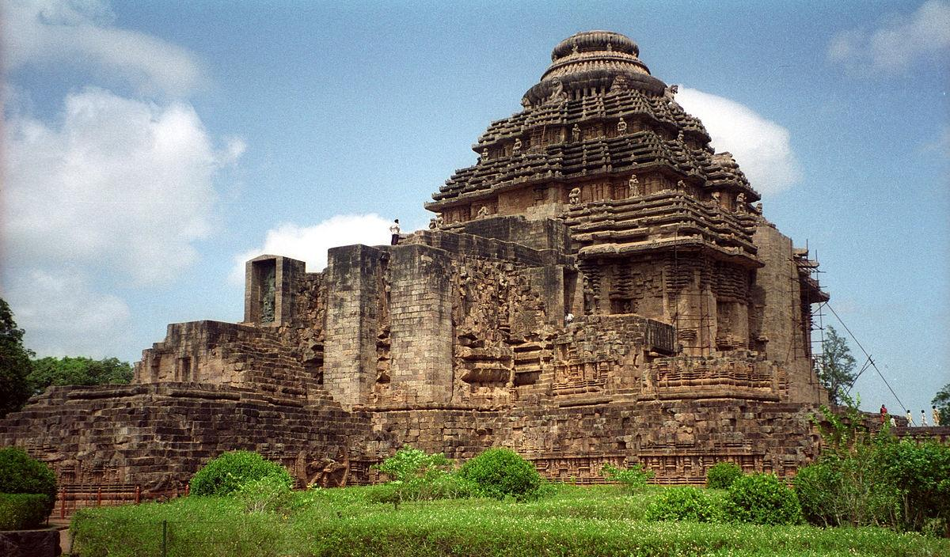
Unfortunately, the main tower has completely collapsed. Today, only its lower portions and archaeological remains give us an idea of its original size and form.

2. Jagamohana – Assembly Hall
The Jagamohana, or main audience/assembly hall, is the most prominent surviving structure.
Unlike the main tower, it is still standing, although it has been heavily damaged and its interior was later filled and sealed for structural protection.
Its massive walls, sculptures and exterior carvings give us a good idea of how magnificent the original temple must have been.
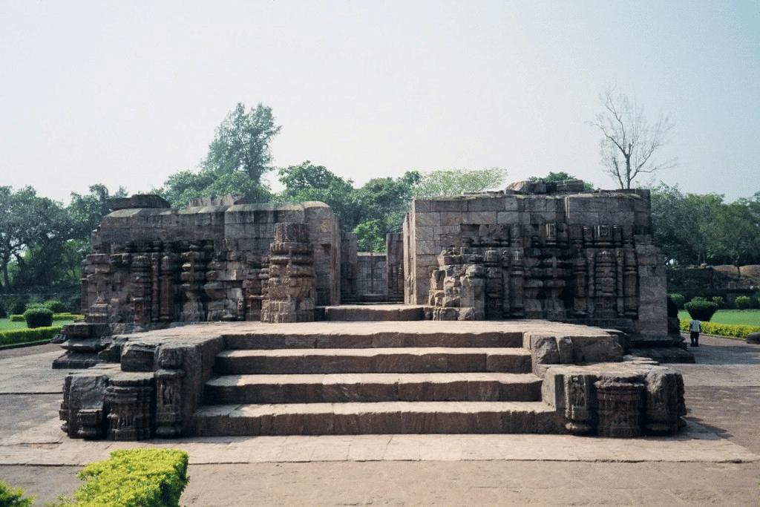

3. Natamandira – Dance Hall
The Natamandira, or dance hall, was located in front of the main temple.
Its roof and upper structure have disappeared, leaving mainly the platform, pillars and lower architectural elements.
The remaining sculptures suggest that this space was connected with dance, music and religious performances.
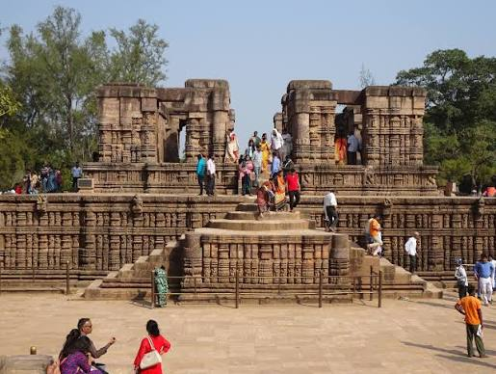

4. Bhoga-Mandapa – Dining/Offering Hall
Another structure associated with the temple complex was the Bhoga-Mandapa, where offerings and ceremonial activities were carried out.
Much of this structure is now in ruins. Only parts of its platform, pillars and stone remains survive.

5. Temple Walls and Sculptures
One of the most impressive yet damaged parts of Konark is its enormous collection of stone carvings.
Many sculptures remain, but some are:
- broken,
- eroded,
- missing,
- partially buried,
- or damaged by weathering.
The fine details of some carvings have become difficult to see because of centuries of exposure to rain, humidity, salt-laden air and wind.

6. Stone Wheels
The famous 24 wheels of the Sun God's chariot are among the best-preserved and most recognizable elements of the temple.
However, even these wheels have experienced damage. Some portions are broken or weathered, and the intricate carvings on their surfaces have deteriorated in places.

7. Horses
The original temple was symbolically designed as the chariot of Surya, pulled by seven horses.
Only some of these horse sculptures survive in recognizable form. Others have been damaged or lost, making the original composition difficult to experience completely today.
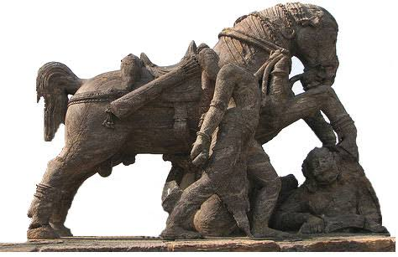

8. Gateway and Other Structures
The original complex also contained entrances, subsidiary shrines, walls and other architectural elements.
Many of these have disappeared or survive only as archaeological remains. What we see today is therefore only part of the original complex.

Reasons for the Destruction of the Konark Sun Temple

1. Structural weakness:The temple was an enormous stone structure with a very tall main tower. Over time, the immense weight placed stress on the foundations and supporting elements. Once important structural parts weakened or failed, sections of the temple became unstable and eventually collapsed.

2. Coastal climate :Konark is close to the Bay of Bengal, so the temple has been exposed to salty, humid air for centuries.
Salt and moisture can enter tiny pores and cracks in stone. Repeated wetting and drying gradually weakens the material and causes the carvings to deteriorate.

3. Heavy monsoon rainfall:Odisha receives strong monsoon rainfall. Water repeatedly flows over and penetrates the stone.
Over many centuries, this contributes to:
- erosion of stone surfaces,
- cracks and weakening,
- growth of moss and microorganisms,
- deterioration of carved details.

4. Cyclones and strong winds:The Odisha coast is highly exposed to cyclones from the Bay of Bengal. Strong winds and heavy rain can damage already weakened architectural elements.
Cyclones are therefore an important environmental factor in the long-term deterioration of the temple.

5. Wind and sand erosion:Because Konark is in a coastal environment, strong winds can carry sand particles. These particles repeatedly hitting the exposed stone can gradually wear down delicate carvings—almost like very slow natural sandpaper.

6. Corrosion of metal elements:The temple's construction included iron/metal components and cramps. In a salty coastal atmosphere, metal can corrode and expand, putting pressure on surrounding stone and contributing to structural deterioration.

7. Earthquakes — a disputed explanation:You may sometimes hear that an earthquake destroyed Konark. However, this should be presented carefully. There is no strong consensus that a single earthquake caused the temple's destruction. The collapse is generally understood as the result of multiple factors acting over time.

8. Human damage and removal of materials:The temple also suffered from human interference over different periods. Some stones and sculptures were damaged, removed or reused, while historical neglect allowed deterioration to continue.

9. Abandonment and lack of maintenance:After the temple ceased to function as an active religious centre, regular maintenance declined. Once cracks, vegetation, water penetration and other problems began, they could gradually become more serious.

Famous Foods Around Konark, Odisha
- Dalma – A traditional Odia dish made with lentils, vegetables and raw papaya, usually eaten with rice. It is one of Odisha's most well-known comfort foods.
- Pakhala Bhata – Cooked rice soaked or fermented in water, usually served with vegetables, fried fish, or other accompaniments. It is especially popular during Odisha's hot weather.
- Chhena Poda – One of Odisha's most famous sweets. It is made from fresh cottage cheese (chhena), sugar and cardamom and then baked until the outside becomes beautifully caramelized.
- Khaja – A crispy, layered sweet made from flour and sugar syrup. It is particularly associated with the Puri–Konark region.
- Mahaprasad – The sacred food traditionally prepared at the Jagannath Temple in Puri. It includes various rice, dal and vegetable preparations and has great religious importance.
- Dahi Bara–Aloo Dum – A popular street food consisting of lentil dumplings soaked in yogurt and served with spicy potato curry. It is especially popular in Odisha.
- Macha Besara – Fish cooked with mustard and spices. Odisha's coastal location makes seafood an important part of its traditional cuisine.

Mysteries of Konark Sun Temple | Secrets of India’s Architectural WonderDocumentary Script & In-Depth Analysis:
The Secrets of Konark Sun Temple
Based on the exploration in Mysteries of Konark Sun Temple | Secrets of India’s Architectural Wonder by The Temple Girl, this documentary treatment analyzes the engineering marvels, ancient magnetic legends, astronomical precision, and the unsolved collapse of Odisha’s 13th-century wonder.
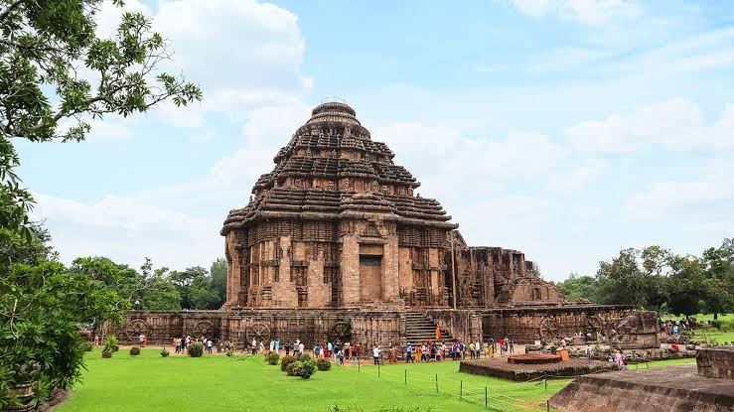
Konark Sun Temple in Odisha. Source: Britannica

Act I: The Monumental Vision in Stone

Scene Overview & Historical Backdrop
On the coastal shores of the Bay of Bengal in Odisha stands the Konark Sun Temple, conceived not merely as a place of worship, but as a colossal, cosmic chariot frozen in stone [00:12].
- The Visionary Patron: Commissioned in the 13th century by King Narasimhadeva I of the Eastern Ganga Dynasty [01:05].
- Monumental Dimensions: Designed as a 229-foot tall stone chariot driven by seven stone horses and mounted on 24 giant stone wheels [01:21].
- Human Feat: Historical accounts and scriptures record that 1,200 master craftsmen and artisans labored for 12 continuous years to sculpt every inch of chlorite, laterite, and khondalite stone [01:30].

Act II: The 52-Ton Magnet and the "Black Pagoda"
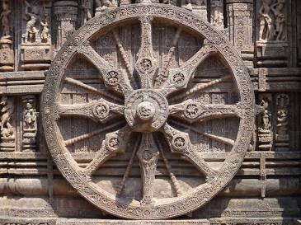
One of Konark's 24 stone wheels. Source: Wikipedia

1. The Magnetic Keystone & Maritime Legend
European mariners navigating the Bay of Bengal dubbed Konark the "Black Pagoda" [02:09].
- The 52-Ton Lodestone: Legends claim that the crowning peak of the main sanctuary tower (Vimana) was capped with a massive 52-ton natural magnet [02:16].
- Structural Cohesion: According to architectural lore, this lodestone acted as an invisible magnetic keystone, keeping heavy iron-clamped stone blocks balanced in equilibrium [02:26].
- Disrupted Compasses & Shipwrecks: Sailors reported that the magnetic field pulled seafaring vessels toward the shallow sands, sending magnetic compasses spinning uncontrollably [02:33].

2. The Levitating Solar Deity
Inside the sanctum sanctorum (Garbhagriha), an idol of the Sun God (Surya) reportedly defied gravity [03:04]:
- Opposing Magnetic Flux: The floating effect was said to be achieved by suspending an iron/metal alloy statue between two powerful magnetic fields—the 52-ton lodestone pulling upward from the Kalasha and an equally potent magnetic slab embedded in the bedrock pushing from beneath [03:19].
- Ancient Levitation: If true, this represents an advanced application of magnetic balance centuries before modern electrodynamics [03:42].

Act III: Horology in Stone — The 24 Astronomical Wheels
The 24 wheels carved along the temple’s plinth are precision horological instruments [04:23].
Feature | Architectural / Astronomical Meaning | Practical Function
24 Wheels | Represents the 24 fortnights (Pakshas) or 24 hours of the cosmic day [05:08]. | Acts as individual sundials and calendars.
8 Major & 8 Minor Spokes | Divides day and night into eight 3-hour periods (Prahars). | Provides calibrated sub-divisions for shadow casting.
Axle Shadow Reading | Guides place a finger on the central hub axle to observe where the shadow intersects beads and carvings [04:38]. | Calculates exact local solar time accurate to the minute [04:45].

Act IV: The Carvings — Worldly Passions to Transcendental Realm
The exterior facades present thousands of intricately detailed bas-reliefs featuring celestial musicians, war elephants, dancers, deities, and explicit erotic (mithuna) sculptures [05:30].
- Tantric Philosophy: Unifying mundane human existence (Kama and Artha) as necessary foundational stepping stones toward spiritual liberation (Moksha) [06:16].
- The Pilgrim's Test: Acting as a psychological test of focus, challenging the devotee to look past earthly desires before entering the inner sanctum [06:23].
- Architectural Grounding Lore: A folklore theory that the thematic stone motifs served symbolic protection against lightning strikes [06:37].

Act V: The Mystery of the Colossal Collapse
While the Jagamohana (Assembly Hall) still stands, the 229-foot main Vimana collapsed, leaving behind a dramatic archaeological puzzle [06:53].
Theories of Konark's Ruin
│

▼ ▼ ▼
[Naval Attack] [Military Invasion] [Geological Reality]
Portuguese removed the General Kalapahad's Weak coastal sands,
52t magnet, causing the 16th-century raid immense dead weight,
entire magnetic balance damaging structural and seismic shocks
to collapse [00:07:15]. support [00:07:31]. caused natural ruin [00:07:39].

Conclusion: A Masterpiece of Integrated Science & Faith
Konark stands as an enduring monument where astrophysics, mathematics, artistic mastery, and sacred architecture converge [08:55]. Whether brought down by foundation subsidence, human conflict, or the removal of its lodestone, its surviving sundials and assembly halls remain one of the ancient world's most sophisticated scientific monuments [08:25].

Source - https://whc.unesco.org/en/list/246/

Outstanding Universal Value
Brief synthesis
The Sun Temple at Konârak, located on the eastern shores of the Indian subcontinent, is one of the outstanding examples of temple architecture and art as revealed in its conception, scale and proportion, and in the sublime narrative strength of its sculptural embellishment. It is an outstanding testimony to the 13th-century kingdom of Orissa and a monumental example of the personification of divinity, thus forming an invaluable link in the history of the diffusion of the cult of Surya,the Sun God. In this sense, it is directly and materially linked to Brahmanism and tantricbelief systems. The Sun Temple is the culmination of Kalingan temple architecture, with all its defining elements in complete and perfect form. A masterpiece of creative genius in both conception and realisation, the temple represents a chariot of the Sun God, with twelve pairs of wheels drawn by seven horses evoking its movement across the heavens. It is embellished with sophisticated and refined iconographical depictions of contemporary life and activities. On the north and south sides are 24 carved wheels, each about 3 m in diameter, as well as symbolic motifs referring to the cycle of the seasons and the months. These complete the illusionary structure of the temple-chariot. Between the wheels, the plinth of the temple is entirely decorated with reliefs of fantastic lions, musicians and dancers, and erotic groups. Like many Indian temples, the Sun Temple comprises several distinct and well-organized spatial units. The vimana (principal sanctuary) was surmounted by a high tower with a shikhara (crowning cap), which was razed in the 19th century. To the east, the jahamogana (audience hall) dominates the ruins with its pyramidal mass. Farther to the east, the natmandir (dance hall), today unroofed, rises on a high platform. Various subsidiary structures are still to be found within the enclosed area of the rectangular wall, which is punctuated by gates and towers.The Sun Temple is an exceptional testimony, in physical form, to the 13th-century Hindu Kingdom of Orissa, under the reign of Narasimha Deva I (AD 1238-1264). Its scale, refinement and conception represent the strength and stability of the Ganga Empire as well as the value systems of the historic milieu. Its aesthetical and visually overwhelming sculptural narratives are today an invaluable window into the religious, political, social and secular life of the people of that period. The Sun Templeis directly associated with the idea and belief of the personification of the Sun God, which is adumbrated in the Vedas and classical texts. The Sun is personified as a divine being with a history, ancestry, family, wives and progeny, and as such, plays a very prominent role in the myths and legends of creation. Furthermore, it is associated with all the legends of its own artistic creation – the most evocative being its construction over twelve years using 1,200 artisans – and the stories about the deep commitment of its master builder, Bisu Moharana, to the project, in which his son (who was born during this period) later became involved. Konârak’s location and name are important testimonies to all the above associations, and its architectural realisation is associated with the living traditions of Brahmanismand tantricpractices.
Criterion (i): A unique artistic achievement, the temple has raised up those lovely legends which are affiliated everywhere with absolute works of art: its construction caused the mobilization of 1,200 workers for 12 years. The architect, Bisu Moharana, having left his birthplace to devote himself to his work, became the father of a son while he was away. This son, in his turn, became part of the workshop and after having constructed the cupola of the temple, which his father was unable to complete, immolated himself by jumping into space.
Criterion (iii): Konârak is an outstanding testimony to the 13th-century kingdom of Orissa.
Criterion (vi): Directly and materially linked to the Brahman beliefs, Konârak is the invaluable link in the history of the diffusion of the cult of Surya, which originating in Kashmir during the 8th century, finally reached the shores of Eastern India.
Integrity
The boundaries of the nominated property encompass the attributes necessary to represent the Outstanding Universal Value of the Sun Temple, Konârak. Within the inscribed and protected extent of the property, its surviving structures and sculptures, as well as the dislodged remains preserved in-situ, represent its quintessential qualities of architectural form, design and sculptural relief. Furthermore, the protected zone includes all areas that have the potential to reveal any unexplored archaeological remains that may possibly enhance the understanding of the property’s Outstanding Universal Value. Identified and potential threats to the integrity of the property include development pressure: modernisation and urban growth affecting the environment of the monument; environmental pressure: deforestation due to cyclones and human activities, saline breeze and sand blasting, vehicular movements, and microbiological growth; tourism pressure: 40% increase in number of tourists; natural disasters: flood and cyclones; and local population growth. An extension of the site boundaries and the buffer zone around the property by land acquisition has been recommended for the better management of the site. Concerns over the structural integrity of elements of the site have been raised in the past, including the impact of monsoon rains and associated soil erosion. In addition, erosion of metal cramps supporting the structure due to salt air has in the past resulted in some damage.
Authenticity
The Sun Temple’s authenticity of form and design is maintained in full through the surviving edifices, their placement within the complex, structures and the integral link of sculpture to architecture. The various attributes of the Sun Temple, including its structures, sculptures, ornamentation and narratives, are maintained in their original forms and material. Its setting and location are maintained in their original form, near the shore of the Bay of Bengal. In preserving the attributes as stated, the Sun Temple, Konârak repeatedly evokes the strong spirit and feeling associated with the structure, which is manifested today in the living cultural practices related to this property, such as the Chandrabhanga festival.
Protection and management requirements
The Sun Temple, Konârak is protected under the National Framework of India by the Ancient Monuments and Archaeological Sites and Remains (AMASR) Act (1958) and its Rules (1959). Other relevant protective legislation includes the Forest Act, Konârak Development Act and notified Council Area Act. Under the AMASR Act, a zone 100 metres outside the property and a further zone 200 metres outside the property constitute, respectively, prohibited and regulated zones for development or other similar activity that may have adverse effects on the Outstanding Universal Value of the property. All conservation programmes are undertaken by the Archaeological Survey of India through its national, regional and local representatives. There are five management-related plans: safety, environment, master planning, environmental development and tourism. World Heritage funding was received to carry out an assessment of structural stability.Sustaining the Outstanding Universal Value of the property over time will require continuing the structural and material conservation of the main Jagamohana structure and its sculptures; establishing a stronger functional integration of local and central authorities; including the larger landscape setting into the regulated area for development; and addressing the identified threats related to development pressure, environmental pressure, tourism pressure, natural disasters, and local population growth.

How it’s calculate it the time
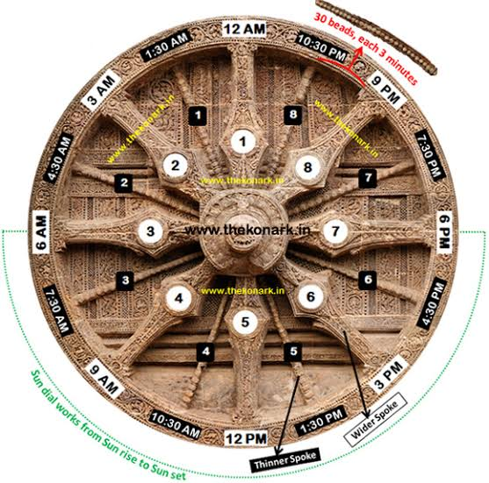
1. The Mathematical Breakdown of the Wheel
Each sundial wheel functions in an anti-clockwise direction (mirroring the sun's trajectory across the southern sky in the Northern Hemisphere):
- 8 Major (Wider) Spokes (45∘ apart): Divide a 24-hour cycle into 8 equal periods of 3 hours each (known as a Prahar in traditional Indian horology). The top central spoke marks midnight (12:00 AM), the leftmost marks sunrise (~6:00 AM), the bottom marks noon (12:00 PM), and the rightmost marks sunset (~6:00 PM).
- 8 Minor (Thinner) Spokes (22.5∘ apart): Each minor spoke sits precisely in the middle of two major spokes, bisecting the 3-hour window into 90-minute (1.5-hour) segments.
- 30 Carved Beads on the Outer Rim (0.75∘ per bead): Between any major spoke and its adjacent minor spoke, the outer perimeter contains exactly 30 carved beads.
30 beads90 minutes​=3 minutes per bead

2. Step-by-Step Method to Read the Time
Step | Action | Measurement Value
1. Cast the Gnomon Shadow | Place a finger, stylus, or pin on the central axle hub. The shadow extends outward across the wheel's face toward the rim. | Baseline directional angle
2. Identify the Base Spoke | Locate the preceding major spoke in the counter-clockwise direction (e.g., the 6:00 AM spoke). | +6 hours
3. Check the Minor Spoke | If the shadow passes the minor spoke between 6:00 AM and 9:00 AM, add 90 minutes (7:30 AM base). | +90 minutes
4. Count the Beads | Count how many individual beads the shadow has crossed past the nearest spoke. Each full bead adds 3 minutes. | Beads×3 min
5. Sub-Bead Precision | Because the sculpted beads are physically wide, observers can distinguish whether the shadow edge falls at the leading edge, center, or trailing edge of a bead. | Accuracy down to 1 minute

3. Worked Example
Imagine placing a marker at the axle during the morning:
- The shadow falls between the 6:00 AM major spoke and the 9:00 AM major spoke.
- It has crossed the intermediate minor spoke (7:30 AM).
- The shadow intersects the 14th bead past that minor spoke:
14×3 minutes=42 minutes
- Adding this to the 7:30 AM mark gives 8:12 AM. If the shadow sits slightly past the center of the 14th bead, the observer reads it as 8:13 AM.

Source - https://culture.gov.in/sun-temple-konarak

Frequently Asked Questions – Konark Sun Temple
1. Where is the Konark Sun Temple located?
The temple is located at Konark in Puri district, Odisha, near the Bay of Bengal.
2. Who built the Konark Sun Temple?
It was built by King Narasimhadeva I of the Eastern Ganga dynasty in the 13th century, around 1250 CE.
3. Who is the temple dedicated to?
The temple is dedicated to Surya, the Hindu Sun God.
4. Why is the temple designed like a chariot?
The temple represents the chariot of Surya, with 24 large stone wheels and horses symbolizing the movement of the Sun.
5. Why is Konark famous?
It is famous for its magnificent stone architecture, detailed sculptures, huge wheels and representation of the Sun God's chariot.
6. Why is the temple partially destroyed?
Its deterioration happened over centuries due to a combination of structural weaknesses, coastal weather, monsoon rainfall, salt-laden air, cyclones, human interference and neglect.
7. What happened to the main temple tower?
The original main sanctum tower (Deul) collapsed, leaving mainly its lower remains. The Jagamohana, or assembly hall, is the most prominent surviving structure.
8. What are the famous 24 wheels?
The 24 wheels are carved stone representations of the wheels of Surya's chariot. Their detailed carvings include geometric patterns, figures and decorative motifs.
9. What is the main material used to build the temple?
The temple was primarily constructed using stone, including Khondalite, along with other stones and metal elements used in its construction.
10. How does the climate affect the temple?
Konark's hot, humid and coastal climate exposes the monument to rain, salt, moisture, wind and biological growth, all of which contribute to stone weathering.
11. Is Konark a UNESCO World Heritage Site?
Yes. The Sun Temple, Konark was inscribed on the UNESCO World Heritage List in 1984.
12. What is the connection between Konark and the Sun?
The temple's eastward orientation, chariot design and Surya sculptures create a strong connection between the monument and the movement and worship of the Sun.
13. What are the famous foods of the Konark/Odisha region?
Some well-known Odia foods include Dalma, Pakhala Bhata, Chhena Poda, Khaja and Dahi Bara–Aloo Dum.
14. What is the best way to understand the ruined temple today?
The surviving walls, wheels, sculptures, pillars and foundations help us reconstruct an idea of how large and elaborate the original temple complex was.
General & Historical FAQs
1. Who built the Konark Sun Temple, and when?
The temple was commissioned in the 13th century (c. 1250 CE) by King Narasimhadeva I of the Eastern Ganga Dynasty to honor the solar deity Surya and commemorate military triumphs.
2. What does the name "Konark" mean?
The name derives from two Sanskrit words: "Kona" (corner/angle) and "Arka" (the Sun), referencing its location on the eastern coastal corner dedicated to the Sun God.
3. Is it a UNESCO World Heritage Site?
Yes. UNESCO declared the Konark Sun Temple a World Heritage Site in 1984 for its exceptional Kalinga architectural and sculptural significance.
4. Why was it called the "Black Pagoda"?
European sailors navigating the Bay of Bengal used the temple’s dark, towering spire as an essential navigational landmark and nicknamed it the "Black Pagoda" (in contrast to the white-plastered Jagannath Temple in Puri, termed the "White Pagoda").

Architecture & Engineering FAQs
5. What is the temple shaped like?
The temple is designed as a colossal cosmic chariot (Ratha) for Surya. It features:
- 24 carved stone wheels (12 pairs, each ~10 feet in diameter).
- 7 stone horses pulling the chariot eastward towards the rising sun.
6. What do the 24 wheels and 7 horses symbolize?
- 7 Horses: The 7 days of the week, the 7 colors of the solar spectrum, and the 7 meters of classical Sanskrit poetic rhythm (chandas).
- 24 Wheels: The 24 fortnights (Pakshas) of the solar year, as well as the 24 hours of the day.
7. How do the sundial wheels calculate time?
Each wheel acts as an astronomical clock. The 8 major spokes divide the day into eight 3-hour periods (Prahars), while the 8 minor spokes break them down further. Carved beads along the rim allow visitors to read the solar shadow down to precise minute intervals.
8. What stone was used in construction?
The temple was constructed using three primary stones:
- Khondalite (main structure and plinths)
- Chlorite (doorframes and detailed central deities)
- Laterite (inner foundations and platform fill)

Mysteries & Legends FAQs
9. What is the legend of the 52-ton magnet and the floating idol?
Local legend holds that the apex (Kalasha) contained a massive 52-ton lodestone (natural magnet) that kept iron-clamped stones in equilibrium and held an iron-alloy statue of Surya suspended in mid-air. Sailors claimed this magnetic force pulled ships toward the shore and disrupted navigational compasses.
10. Why did the main tower (Vimana) collapse?
The 229-foot main sanctuary is no longer standing (only the Jagamohana or assembly hall remains). Archaeologists and historians attribute the collapse to a combination of:
- Structural subsidence due to heavy foundation load on soft coastal sand.
- Gradual neglect after maritime trade shifted.
- Invasions and natural weathering/seismic tremors over centuries.
11. Why are there erotic sculptures on the temple walls?
Like Khajuraho, Konark incorporates Mithuna figures representing the classical Hindu pursuit of Kama (love/desire), forming an integral part of worldly existence that pilgrims acknowledge before entering the sanctum toward Moksha (spiritual liberation).

Visitor & Practical Travel FAQs
Category | Information
Visiting Hours | 6:00 AM – 8:00 PM (Daily / Sunrise to Sunset)
Entry Fee (Indians & SAARC/BIMSTEC) | ₹40 (Cash) / ₹35 (Online via ASI portal)
Entry Fee (Foreign Tourists) | ₹600 (Cash) / ₹550 (Online)
Children (Under 15 years) | Free entry
Best Time to Visit | October to March (pleasant weather)
Nearest Airport | Biju Patnaik International Airport, Bhubaneswar (~65 km)
Nearest Major Railway Station | Puri Railway Station (~35 km) or Bhubaneswar (~65 km)
12. Is photography allowed?
Non-commercial still photography is permitted. Drones and unauthorized commercial video rigs are strictly prohibited under ASI regulations.
13. What annual festival is held at Konark?
The Konark Dance Festival takes place every year (usually in December) at the open-air Natya Mandap against the illuminated temple backdrop, featuring classical Indian dance forms like Odissi, Bharatanatyam, and Kathak.

